**HTML**

Tags

----------------------------------------------------------------

<!DOCTYPE html> </html>

<head>

<Title>

<body>

<center>

<p></p> - to write the paragraphs

<h1-h6> <h1> - main header

<h6> - lowest header

<b>- bold

<i>- italic

<u>- underline

<font> - font the letters

<Style> - style of the letters

<div> -

<input>- entering the text

<a> - link

<button>- submit button

<select>- selecting dropdown

<br>-break the line

HTML5

1. First HTML is introduced in 1999.
2. HTML5 is introduced in 2006.
3. HtML5 is nothing but combination of html, css and Javascripts.

Uses:

1. Device Independent( it will adjust the size according to screen).
2. Reduce the need of javascript for form validation.
3. New tags is introduced which supports the media
4. Better view of code.

Inside this html5 the first statement should be Doctype and it is mandatory code.

<!DOCTYPE html>

Features of HTML5:

1. New Markup Elements/Tags.
2. New Media tags.
3. Canvas tags and svg tags(Drawing)
4. New Form input tags
5. New Form Attributes
6. Web storages
7. Drag and drop features.

**Markup Elements:**

The tags which are used in desigining the web site is markup elements.

In HTML5 , some rules while using Markup elements

1. <!DOCTYPE html> is compulsory.
2. Independent tags should be closed.

<br/>

1. Only one root element should be kept.

<html><head><title><body>

1. All the properties values should be in double quotation.
2. Property minimization is avoided.

Sample Program

<!DOCTYPE html>

<html>

<head>

<title>

</title>

</head>

<body>

</body>

</html>

**Address Element/Tag:**

It is used to store the address of the website or author details.

The text in the address tag will come in Italic and in different style.

Ex:

<address>

        K7 Info Tech, <br/>

        3rd cross, Jayanthi Nagar,<br/>

        Horamavu,<br/>

        Bangalore-560043.

     </address>

2. Aside Tag/Element:

Aside tag is used store the related information in the webpage.

Ex:

<p> My Family and me went to the Tirumala in summer</p>

   <aside>

    <h3>Tirumala</h3>

    <p>Tirumala is one of the famous spritual and historical place in the world. </p>

    <p> Tirupati is our native place </p>

   </aside>

**Article Element:**

It is used to store the self-articles in the webpage.

The browser will treat entire text as a single article.

<article></article>

 <article>

    <h1>k7it</h1>

    <p>Welcome to K7it</p>

    <p> This is sample article of k7it</p>

   </article>

**Base Tag/ Element:**

It is one of the important tag in HTML5. It is used to provide default linking and default target for all the hyperlinks tags in webpage.

This tag is used in the head tag only.

<head>

    <title>

        New Mark up Elements

    </title>

    <base href="https://www.infosys.com/" target="_new"/>

    </head>

<body>

<a href="">HOME</a>

   <a href="careers">CAREERS</a>

   <a href="investors.html">INVESTORS</a>

   </body>

**BlockQuote Element:**

It is used to place the text seperatly in a blockquotes( it will give the tab space in the front and after the end of the text.)

<blockQuote></blackquote>

<p text-align="justify">

    Check For Updates </br>

    <blockquote>

        We use cookies to personalise content and ads,

        to provide social media features and to analyse our traffic.</br>

        We also disclose information about your use of our site with our social media, advertising and analytics partners. </br>

        Additional details are available in ourCookie Policy

    </blockquote>

**Details Tag/Element:**

It is used to store some extra information about any text. In this Details tag, there is a sub tag called summary tag.

Summary tag is used to display the text.

Syntax:

<details>

    <summary>

        K7IT introduced in 2022 and Copy right information

    </summary>

    This is certified copy.

   </details>

**Figure and Figcaption tag/ Element:**

Figure element to used to display the picture/photo in Web Page. Figcaption tag is used to display the caption for the corresponding picture.

Syntax:

<figure>

<img src=” C:\Users\Dell\Downloads\logo.png”/>

<figcaption> This is k7IT logo</figcaption>

</figure>

<figure>

    <img src="c:\Users\Dell\Downloads\Image.jpg"/>

    <figcaption>This is beautiful nature in India</figcaption>

</figure>

**Header Tag/Element:**

Header Element contains some information regarding the header.

Syntax:

<header>

This is related to header tag.

</header>

<header>

        <font color ="red" size="2">

            <h1>

            This is related  to header tag.

        </h1>

        </font>

        </header>

**Nav Tag:**

This Nav tag is used to display the related links and menu bars.

<nav>

   <a href="">HOME</a> |

   <a href="careers">CAREERS </a>|

   <a href="investors.html">INVESTORS </a>|

</nav>

**Section Tag:**

Section tag is used to separate the information in the webpage.

<section>

    <h4>Abdul Kalam</h4>

    <p>Abdul kalam is one of the greatest Aeronatical Scientist in India. He is eleventh President of India.</p>

   </section>

   <section>

    <h4>Mahatma Gandhi</h4>

    <p> Mahatma Gandhi is father of nation. He is one of the freedom fighter</p>

   </section>

   <section>

    <h4>Mother Teresa</h4>

    <p>Mother Teresa is one of the greatest woman who service the poor people in India.</p>

   </section>

**Footer Tag/Element:**

Footer tag is used to store the information like copyrights , social media icons, contact information .

 <footer>

      © Copyright K7 Infotech. All Rights Reserved

      Designed by K7

     copy rights is company is @2022 and Facebook links, istagram pages, twitter icon.

   </footer>

Semantic Tags:

All these above tags are called as semantic tags which is used to design the web pages.

<header>

This is header Information

</header>

<body>

<nav>

<section>

<articles>

</articles>

</section>

</nav>

</body>

<footer>

</footer>

**Hgroup Tag:**

Heading tags(h1-h6)

Syntax:

<h1>Welcome K7it</h1>

<h2> Good Morning</h2>

<h6> ………….</h6>

**Mark Tag:**

Mark tag is used to highlight the text with yellow color background.

<p>

    Today

    <mark>Don't forget to come to class</mark>

    and finish your task.

   </p>

**Meter tag:**

It is used to create a meter(gauge).

 <meter value="0.99" low="0.2" high="0.9" optimum="0.5">

   </meter>

**Progress Tag:**

It is used to get the progress bar.

 <progress value="9" max="100" min="10">

   </progress>

**Time Tag:**

It is used to specify the browser that this is a time and it is also used to indicate the date.

It is used to encode dates and times in a machine-readable way to make easy to mark or schedule your task.

<p>we are going to dinner today at <time>9:00</time> pm</p>

   <p> Tommorow my lucky birthday party <time date="2023-04-21" > 7:30</time>pm at our home.</p>

**Wbr tag:**

Word break tag.

When a word is too long, the browser might break it at the wrong place. You can use the <wbr> element to add word break opportunities.

welcome to k7it. In K7It i am going to<wbr>teachtheHTMLXMLrequestmappingresponsemappingpostmappingupdatemappingrequestandresponse</wbr>

These Elements are called as Mark up Elements.

Ex:

<!DOCTYPE html>

<html>

<head>

    <title>

        New Mark up Elements

    </title>

    <base href="https://www.infosys.com/" target="_new"/>

    </head>

    <header>

        <font color ="red" size="2">

            <h1>

            This is related  to header tag.

        </h1>

        </font>

        </header>

<body>

    <address>

        K7 Info Tech, <br/>

        3rd cross, Jayanthi Nagar,<br/>

        Horamavu,<br/>

        Bangalore-560043.

     </address>

   Welcome K7IT

   <p> My Family and me went to the Tirumala in summer</p>

   <aside>

    <h1>Tirumala</h1>

    <p>Tirumala is one of the famous spritual and historical place in the world. </p>

    <p> Tirupati is our native place </p>

   </aside>

   <article>

    <h1>k7it</h1>

    <p>Welcome to K7it</p>

    <p> This is sample article of k7it</p>

   </article>

<nav>

   <a href="">HOME</a> |

   <a href="careers">CAREERS </a>|

   <a href="investors.html">INVESTORS </a>|

</nav>

   <p text-align="justify">

    Check For Updates </br>

    <blockquote>

        We use cookies to personalise content and ads,

        to provide social media features and to analyse our traffic.</br>

        We also disclose information about your use of our site with our social media, advertising and analytics partners. </br>

        Additional details are available in ourCookie Policy

    </blockquote>

   </p>

   <details>

    <summary>

        K7IT introduced in 2022 and Copy right information

    </summary>

    This is certified copy.

   </details>

<figure>

    <img src="c:\Users\Dell\Downloads\Image.jpg"/>

    <figcaption>This is beautiful nature in India</figcaption>

</figure>

<details>

    <summary>

        Abdul Kalam

    </summary>

    Abdul kalam is one of the greatest Aeronatical Scientist in India. He is eleventh President of India.

</details>

   <section>

    <h4>Abdul Kalam</h4>

    <p>Abdul kalam is one of the greatest Aeronatical Scientist in India. He is eleventh President of India.</p>

   </section>

   <section>

    <h4>Mahatma Gandhi</h4>

    <p> Mahatma Gandhi is father of nation. He is one of the freedom fighter</p>

   </section>

   <section>

    <h4>Mother Teresa</h4>

    <p>Mother Teresa is one of the greatest woman who service the poor people in India.</p>

   </section>

   <p>

    Today

    <mark>Don't forget to come to class</mark>

    and finish your task.

   </p>

   <meter value="0.99" low="0.2" high="0.9" optimum="0.5">

   </meter>

</br>

   <progress value="9" max="100" min="10">

   </progress>

   <p>we are going to dinner today at <time>9:00</time> pm</p>

   <p> Tommorow my lucky birthday party <time date="2023-04-21" > 7:30</time>pm at our home.</p>

   <p>we are going to dinner today at 9:00 pm.</p>

   welcome to k7it. In K7It i am going to <wbr>teachtheHTMLXMLrequestmappingresponsemappingpostmappingupdatemappingrequestandresponse</wbr>

   </body>

   <footer>

      © Copyright K7 Infotech. All Rights Reserved

      Designed by K7

     copy rights is company is @2022 and Facebook links, istagram pages, twitter icon.

   </footer>

</html>

Output:

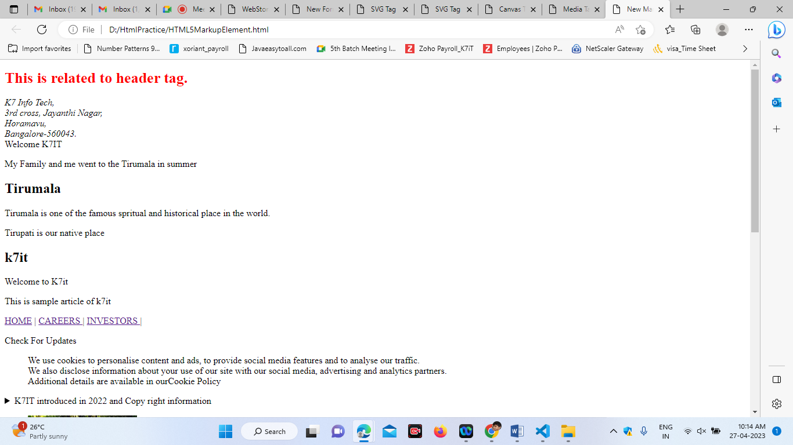

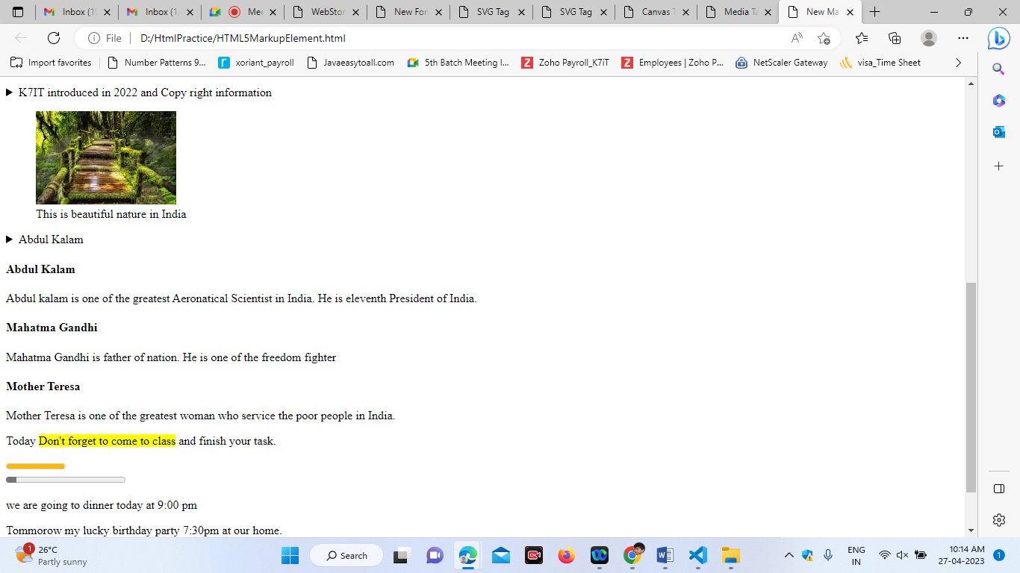

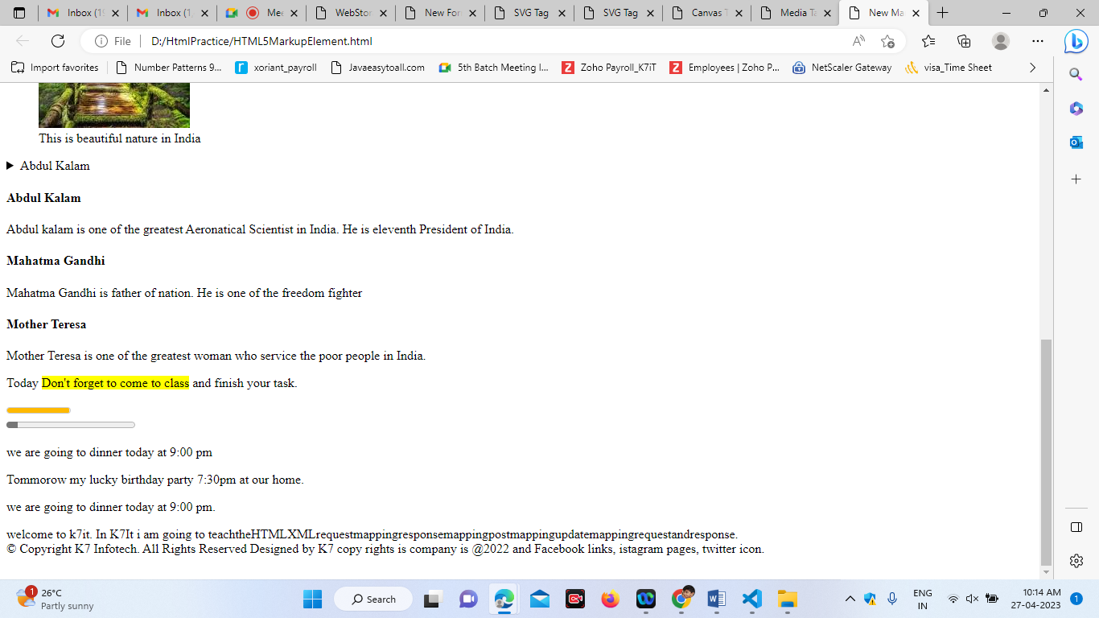

2. **Media Tags**

**1.** Video tags

2. audio tags

1. Video Tag:

In html we are going to insert the videos in our web pages.

Syntax:

<video> </video>

Properties in video tags:

1. Height
2. Width
3. Loop- to make the video loop.
4. Autoplay – play the video automatically when page opens
5. Poster – it will give some image to display before when we start the video.
6. Muted- when audio wants to mute.
7. Src – the path of the video.

Browser Compatability:

* IE will supports .mp4 format
* Firefox will support only .ogg format, webm format
* Chrome supports all the formats .mp4,.ogg

 <video  heigth="500" width="400" controls="controls" autoplay="autoplay" loop="loop" muted="muted" poster="C:\Users\Dell\Downloads\Image.jpg">

            <source src="https://file-examples.com/storage/feee5c69f0643c59da6bf13/2018/04/file_example_OGG_480_1_7mg.ogg" type="video/ogg" >

        </video>

**Audio tags:**

<audio></audio>

Properties in video tags:

1. Height
2. Width
3. Loop- to make the audio loop.
4. Autoplay – play the audio automatically when page opens
5. Muted- when audio wants to mute.
6. Src – the path of the audio.
7. <audio heigth="100" width="100" controls="controls" autoplay="autoplay" loop="loop" muted="muted">
8. <source src="https://file-examples.com/storage/feee5c69f0643c59da6bf13/2017/11/file_example_MP3_700KB.mp3" type="audio/mp3">
9. </audio>

Html:

<!DOCTYPE html>

<html>

    <head>

        <title> Media Tags</title>

    </head>

    <body>

        <video  heigth="500" width="400" controls="controls" autoplay="autoplay" loop="loop" muted="muted" poster="C:\Users\Dell\Downloads\Image.jpg">

            <source src="https://file-examples.com/storage/feee5c69f0643c59da6bf13/2018/04/file_example_OGG_480_1_7mg.ogg" type="video/ogg" >

        </video>

        <audio heigth="100" width="100" controls="controls" autoplay="autoplay" loop="loop" muted="muted">

            <source src="https://file-examples.com/storage/feee5c69f0643c59da6bf13/2017/11/file_example_MP3_700KB.mp3" type="audio/mp3">

        </audio>

    </body>

</html>

Output:

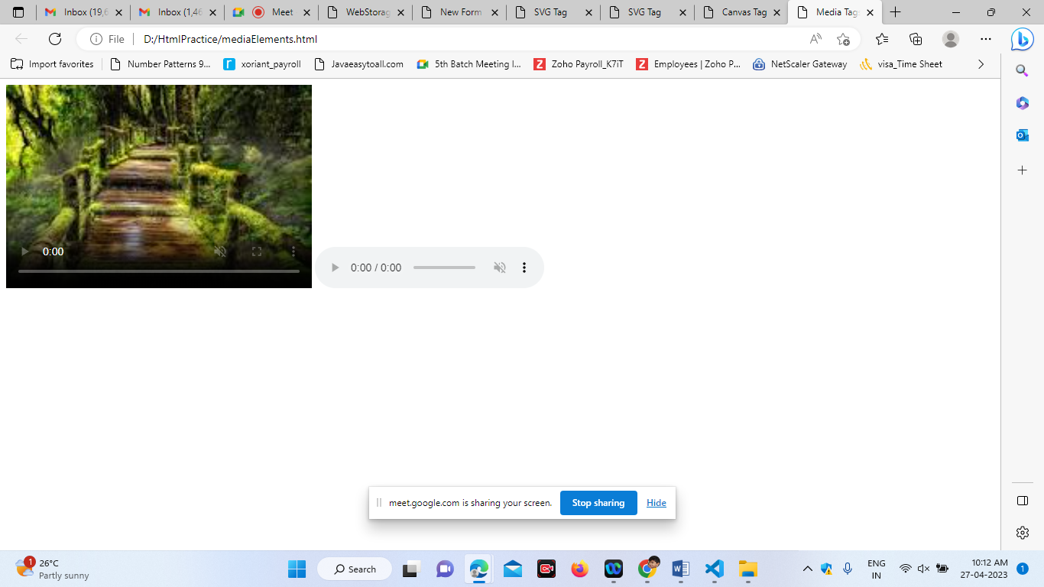

**Canvas Tag**

Canvas tag is used for the drawing purpose. Whatever we are drawing is in pixels.

Canvas is an rectangle area in which every pixel is controlled.

If you want to draw anything inside the canvas we shouls use the script.

Syntax:

<canvas style= “border:3px solid red”>

</canvas>

Example:

<!DOCTYPE html>

<html>

    <head>

        <title> Canvas Tag</title>

    </head>

    <body>

        <canvas id="mycanvas" height="300" width="500" style="border:3px solid gray">

        </canvas>

        <script type="text/javascript">

            var c= document.getElementById("mycanvas");

            var context=c.getContext("2d");

            /* drawing some rectangle box*/

            context.fillStyle="green";

            context.fillRect(100,80,200,160);

            /* drawing circle*/

            context.fillStyle="blue";

            context.beginPath();

            context.arc(100,100,50,0,Math.PI*2,false);

            context.closePath();

            context.fill();

            /* drawing the line*/

            context.moveTo(100,150);

            context.lineTo(200,200);

            context.lineTo(80,90);

            context.strokeStyle="red";

            context.lineCap="round";

            context.lineWidth="2";

            context.stroke();

        </script>

    </body>

</html>

Output:

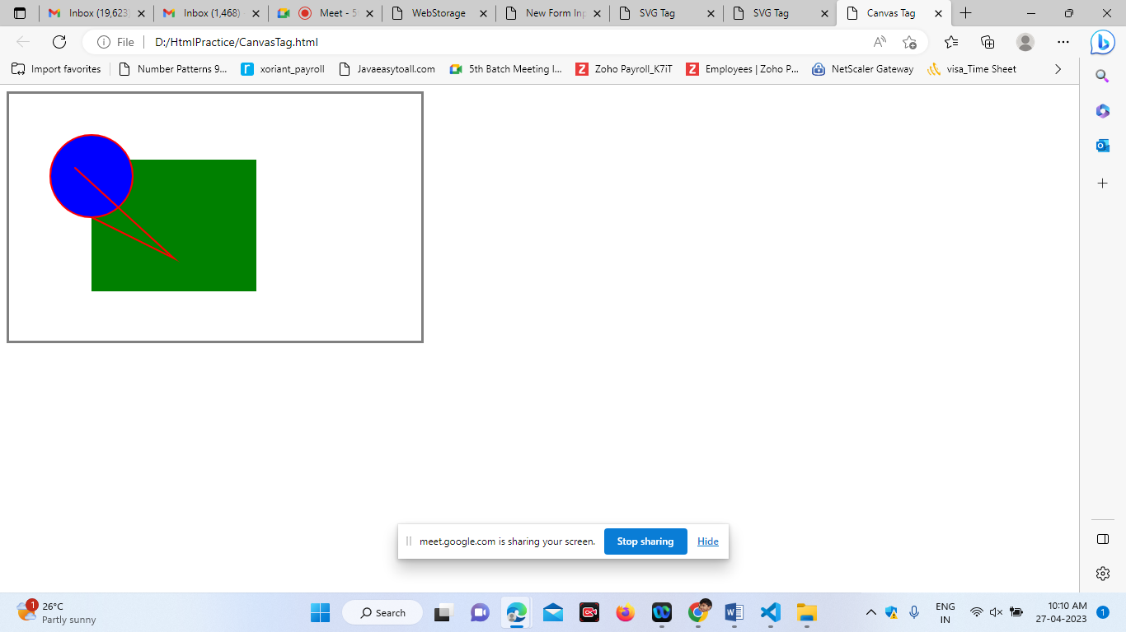

**SVG Tag:**

By using svg tag we can draw the shapes in web page.

SVG(Scalable Vector Graphics):

It is also drawn in format of pixels. It is 2d coordinate system.

Syntax:

<svg height=”100” width=”200”>

Rectangle:

 <svg height="500" width="300">

            <rect x="20" y="10" height="200" width="500" fill="#00008B" stroke="#FFFF00" stroke-width="5"></rect>

        </svg>

Circle:

<svg width="200" height="100">

            <circle cx="100" cy="50" r="50" fill="#800000" stroke="#008000" stroke-width="5"></circle>

        </svg>

Ellipse:

 <svg width="200" height="300">

            <ellipse cx="100" cy="90" rx="75" ry="40" fill="#008000"></ellipse>

        </svg>

Polygon:

<svg width="200" height="500">

            <polygon points="100,40,40,140,180,40,60,80,100,120" fill="#008000" stroke="#000000"></polygon>

        </svg>

Line:

<svg width="200" height="100">

            <line x1="10" y1="20" x2="100" y2="200" stroke="#800000"stroke-width="3"></line>

        </svg>

Adding the text inside the rectangle :

<svg height="500" width="300">

            <rect x="20" y="10" height="200" width="500" fill="#00008B" stroke="#FFFF00" stroke-width="5"></rect>

            <text x="50" y="50" fill="#FFFF00" font-size="20px">Welcome K7IT</text>

            <text x="50" y="70" fill="#FFFF00" font-size="20px">Welcome K7IT Students</text>

        </svg>

Output:

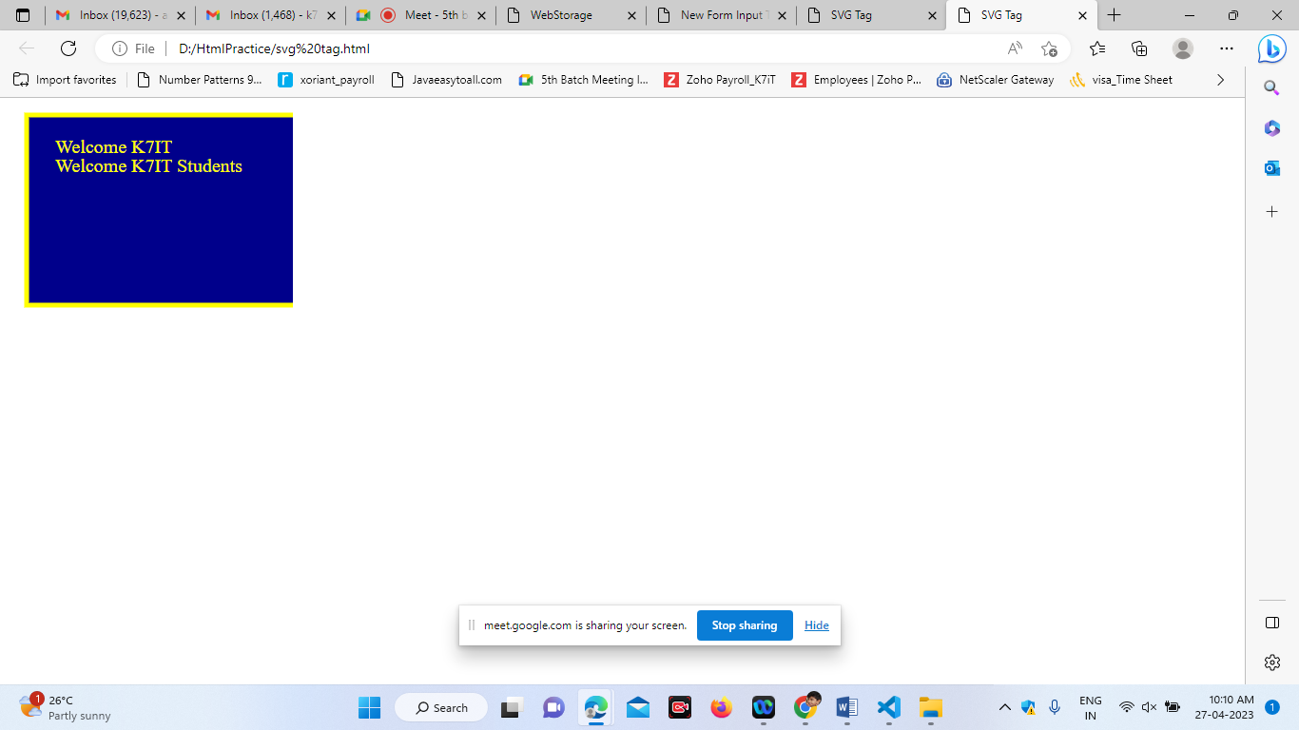

Advantages / benefits of SVG in HTML5 :

1. Scalability
2. Animations
3. Browser compatability
4. Better accessability
5. Quality

**4. New Form Input Tags**

<!DOCTYPE html>

<html>

    <head>

        <title>New Form Input Tags</title>

    </head>

    <body>

        <form>

        <input type="color" name="c1"/></br>

       Date: <input type="date" name="d1"  autofocus="autofocus"/>

       <input type="submit"/>

       Month:<input type="month" name="d1"/>

       <input type="submit"/>

       Week:<input type="week" name="d1"/>

       <input type="submit"/>

       Date and Time: <input type="datetime-local" name="t1"/>

       <input type="submit"/></br>

       Email:<input type="email" name="e1"/>

       <input type="submit"/>

       Number:<input type="number" name="n1" min="0" max="100"/>

       Range:<input type="range" name="r1" min="10" max="100"/>

        <input type="submit"/><br><br>

     <form autocomplete="on">

       UserName:<input type="text" name="uname" autofocus="autofocus"/>

       </br>

       Password:<input type="text" name="pass"  autofocus="autofocus"/><br>

       Email:<input type="email" name="email" autocomplete="off"/><br>

       <input type="submit"/>

       URL:<input type="url" list="list1"/>

       <datalist id="list1">

        <option value="http://google.com"></option>

        <option value="http://yahoo.com"></option>

        <option value="http://facebook.com"></option>

        <option value="http://twitter.com"></option>

       </datalist>

       <input type="submit"/></br>

       Image Upload:<input type="file" name="f1"  multiple="multiple"/><br>

       <input type="submit"/>

       </form>

    </body>

</html>

Output:

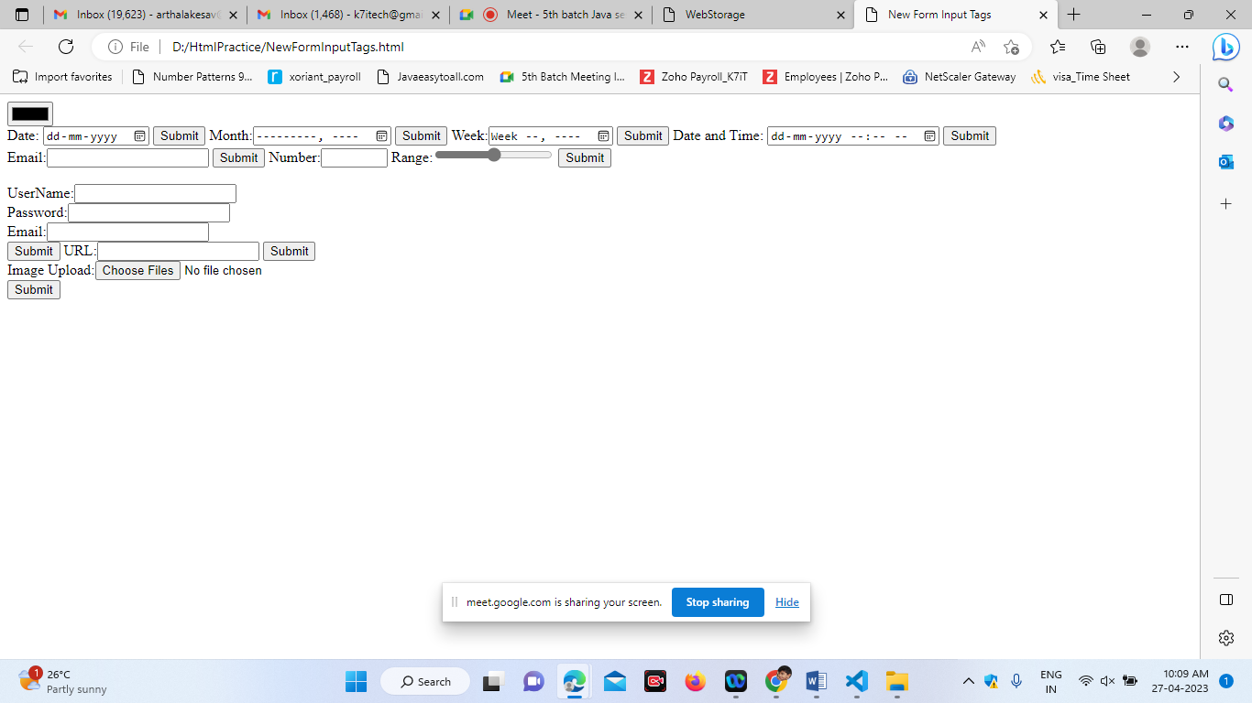

**5.WebStorage:**

WebStorage is used to store the data in the client side browsers.

WebStorage are 2 type:

1. Local Storage
2. Session storage.

**Local Storage:** Local Storage is used to storage the data permanent in the browser.

<!DOCTYPE html>

<html>

    <head>

        <title>WebStorage</title>

    </head>

    <body>

        <button id="storedata" >StoreData</button>

        <button id="retrievedata">RetriveData</button>

        <p id="output"></p>

        <p id="output1"></p>

        <p id="output2"></p>

    <script>

        const storageDatabtn= document.querySelector("#storedata");

        const retrieveDatabtn=document.querySelector("#retrievedata");

        const output=document.querySelector("#output");

        const output1=document.querySelector("#output1");

        const output2=document.querySelector("#output2");

        storageDatabtn.addEventListener("click",function(){

            localStorage.setItem("student","Aruna");

            localStorage.setItem("student1","Anu");

            localStorage.setItem("student2","Babu");

            output.innerHTML="The name of k7it Student is stored";

        });

        retrieveDatabtn.addEventListener("click",function(){

            const data=localStorage.getItem("student");

            output.innerHTML="The Name of the k7it student is: "+data;

            output1.innerHTML="The Name of the k7it student is: "+localStorage.getItem("student1");

            output2.innerHTML="The Name of the k7it student is: "+localStorage.getItem("student2");

        });

    </script>

    </body>

</html>

**Session Storage:** It is used to store the data temporarily in the browser. Whenever the session closed/expired, the data will be deleted from client side browser.

<!DOCTYPE html>

<html>

    <head>

        <title>WebStorage</title>

    </head>

    <body>

        <button id="storedata" >StoreData</button>

        <button id="retrievedata">RetriveData</button>

        <p id="output"></p>

        <p id="output1"></p>

        <p id="output2"></p>

    <script>

        const storageDatabtn= document.querySelector("#storedata");

        const retrieveDatabtn=document.querySelector("#retrievedata");

        const output=document.querySelector("#output");

        const output1=document.querySelector("#output1");

        const output2=document.querySelector("#output2");

        storageDatabtn.addEventListener("click",function(){

            sessionStorage.setItem("student","Aruna");

            sessionStorage.setItem("student1","Anu");

            sessionStorage.setItem("student2","Babu");

            output.innerHTML="The name of k7it Student is stored";

        });

        retrieveDatabtn.addEventListener("click",function(){

            const data=sessionStorage.getItem("student");

            output.innerHTML="The Name of the k7it student is: "+data;

            output1.innerHTML="The Name of the k7it student is: "+sessionStorage.getItem("student1");

            output2.innerHTML="The Name of the k7it student is: "+sessionStorage.getItem("student2");

        });

    </script>

    </body>

</html>

Output :

